Chapter 14, Solution 59.

Consider the circuit below.
R
sL
1/sC
R_{o}
+
-
V_{i}
+

V_{o}

-

where L = 1 mH, C = 4 µF, R_{o} = 6 Ω, and R = 4 Ω.

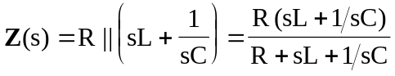

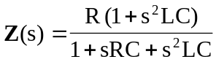

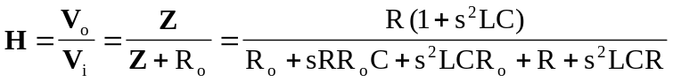

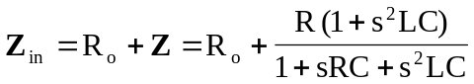

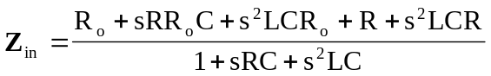

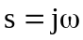
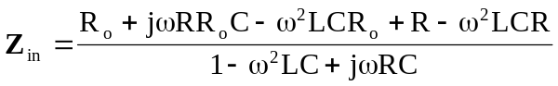

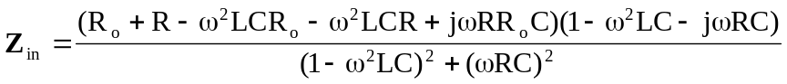

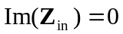 implies that

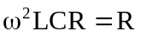

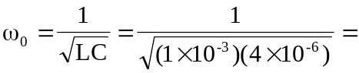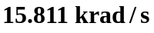

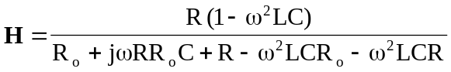

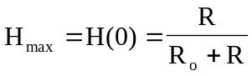
or 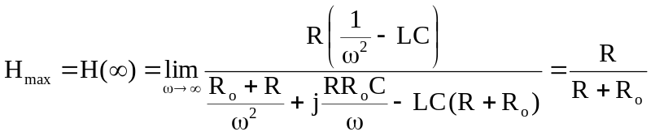

At 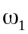 and 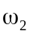, 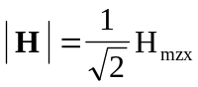

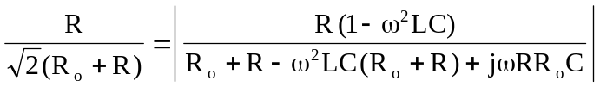

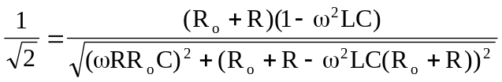

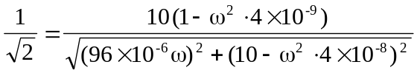

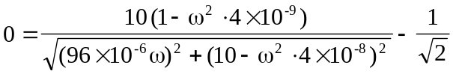

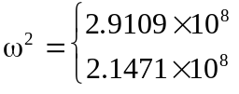

Hence,
